

**INSTITUTE FOR ADVANCED COMPUTING**

**AND**

**SOFTWARE DEVELOPMENT AKURDI,**

**PUNE**

**Documentation On**

**“SCHOOL MANAGEMENT SYSTEM”**

**e-DAC May 2021**

**Submitted By:**

**Group No: 84**

**Hardik Patil 210541281131**

**Akshay Morale 210541281111**

Prashant Karhale Mr. Chetan Pardeshi

**Centre Coordinator** **Project Guide**

**Contents**

Introduction 3

Document Purpose 3

Problem Statement 3

Product Scope 3

Aims & Objectives 4

Overall Description 5

Product Perspective 5

Existing system function 5

Proposed System 5

Product functionality 5

Benefits of School Management System 6

Users and Characteristics 6

Operating Environment 7

Design and Implementation Constraints 7

Specific Requirement 8

External Interface Requirements 8

User Interfaces 8

Hardware Interfaces 8

Application Interfaces 8

Communications Interfaces 8

System Design 10

Activity Diagram 10

Data Flow Diagram 14

Use Case Diagram 17

ER Diagram 18

Database Design 19

Snapshots 21

Conclusion and Future Scope 26

**Figures**

Figure 1 Authentication and Role Check 11

Figure 2 Admin Activity Diagram 12

Figure 3 Teacher Activity Diagram 13

Figure 4 Student Activity Board 14

Figure 5 Level 0 Data Flow Diagram 15

Figure 6 Level 1 Data Flow Diagram 15

Figure 7 Level 2 Data Flow Diagram For Admin 16

Figure 8 Level 2 Data Flow Diagram For Teacher 17

Figure 9 Level 2 Data Flow Diagram For Student 17

Figure 10 Use Case Diagram 18

Figure 11 ER Diagram 19

Figure 12 User database design 20

Figure 13 Admin database design 20

Figure 14 Student database design 20

Figure 15 Teacher database design 21

Figure 16 Roles database design 21

Figure 17 User_roles database design 21

Figure 18 Feedback database design 21

Figure 19 Snapshot Home Page 22

Figure 20 Snapshot Login Page 22

Figure 21 Snapshot Admin Homepage 23

Figure 22 Snapshot Admin page 23

Figure 23 Snapshot Admin Teacher Section 24

Figure 24 Snapshot Admin Registration 24

Figure 25 Snapshot Admin Teacher_list 25

Figure 26 Snapshot Admin Student_list 25

Figure 27 Snapshot Teacher student_section 26

Figure 28 Snapshot Student Details 26

# Introduction

## Document Purpose

This document communicates the business requirements and scope for developing Online School Management System. The scope of this document is to define the functional and non-functional requirements, business rules and other constraints requirements.

## Problem Statement

Existing system for a school is based on our traditional way keeping records and details on paper and registers. Access of these details and papers are not granted to common member in absence of the authority. It is hard to manage all the school system with pen and paper. It gets really hard to maintain the records and then keep track of past records. Hence this system is proposed to overcome the flaws of the existing system and giving power to the admin of the institution so that he/she will be able to manage the school easily.

## Product Scope

This project traverses a lot of areas ranging from business concept to computing field and required to perform several researches to be able to achieve the project objectives. The area covers include:

• School/Institutions: This includes study on how the daily School work actually is being done, process involved and opportunity that exist for improvement.

• J2EE Technology used for the development of the application.

• General students as well as the school’s staff will be able to use the system effectively.

• Web-platform means that the system will be available for access 24/7 except when there is a temporary server issue which is expected to be minimal.

## Aims & Objectives

Specific goals are: -

**•** To produce a web-based system that allow the admin to add students, faculties and provide functionalities to its role.

• To ease faculties by providing different functionalities to it.

• To ease students to help them in their study by tracking school details and feedback efficiently.

# Overall Description

## Product Perspective

### Existing system function

Existing system for institutions are based on our traditional way keeping records and details on paper and registers. Access of these details and papers are not granted to common member in absence of the authority. The Project School Management System has been developed to help institutions maintaining the user details like student and faculty, earlier the records were maintained manually, with the help of this project concerned institutions will be able to improve productivity, reduce time and cost associated with system

## Proposed System

### Product functionality

School Management System provides the features for admin, teacher and student. It includes several functionalities describes as below:

* **Admin Management:**

It provides facility to add, update, delete and view the students studying in school also the teachers. We can view their details and also update.

* **Teacher Management:**

It provides facility to teacher for updating attendance and feedback about student for particular subject**.**

* **Student Management:**

It provides facility to students to check attendance and feedback provided by teacher which will eventually help them to improve themselves.

## Benefits of School Management System

**•** This school management solution is fully functional and flexible.

• Role based Login and Authentication Mechanism

• User level Filters implementation.

• This online school management system helps in back office administration by streamlining and standardizing the procedures.

• It increases the efficiency of the management at offering quality services to the users.

• It provides custom features development and support with the application.

## Users and Characteristics

**Admin:**

* Admin can login to the system.
* View profile
* View the list of all students admitted in school.
* View the list of all teacher.
* Register student and teacher.
* Update student and teacher.
* Logout of system

**Teacher:**

* Teacher can login to the system.
* View profile
* View the list of all students.
* Add Feedback
* Update attendance
* Logout of system

**Student:**

* Student can login in system
* View profile
* View feedback on subjects
* Logout of system

## Operating Environment

**Server Side:**

Processor: Intel® Xeon® processor 3500 series

HDD: Minimum 500GB Disk Space

RAM: Minimum 2GB OS: Windows 8.1, Linux 6 Database: Oracle 11g

**Client Side (**minimum requirement**):**

Processor: Intel Dual Core

HDD: Minimum 80GB Disk Space

RAM: Minimum 1GB

OS: Windows 7, Linux

## Design and Implementation Constraints

• The application will use ReactJS, React Router, axios and Bootstrap as main web technologies and perform form validation.

• The back-end server uses JAVA 8, Spring Boot 2 (with Spring Security, Spring Web, and Spring Data JPA) and JWT authentication with jjwt and Spring Data JPA for interacting with MySQL database.

• Since Society Management system is a web-based application, internet connection must be established.

• The Society Management System will be used on PCs and will function via internet or intranet in any web browser.

# Specific Requirement

## External Interface Requirements

### User Interfaces

• All the users will see the same page when they enter in this website. This page provides login button which asks the users a username and a password.

• After being authenticated by correct username and password, user based on role will be redirect to their corresponding profile where they can do various activities.

• The user interface will be simple and consistence, using terminology commonly understood by intended users of the system. The system will have simple interface, consistence with standard interface, to eliminate need for user training of infrequent users.

### Hardware Interfaces

• No extra hardware interfaces are needed.

• The system will use the standard hardware and data communication resources.

• This includes, but not limited to, general network connection at the server/hosting site, network server and network management tools.

### Application Interfaces

OS: Windows 7 and above, Linux

Web Browser:

The system is a web-based application; clients need a modern web browser such as Mozilla Firebox, Internet Explorer, Opera, and Chrome. The computer must have an Internet connection in order to be able to access the system.

### Communications Interfaces

• This system uses communication resources which includes but not limited to, HTTP protocol for communication with the web browser and web server and TCP/IP network protocol with HTTP protocol.

• This application will communicate with the database that holds all the booking information. Users can contact with server side through HTTP protocol by means of a function that is called HTTP Service. This function allows the application to use the data retrieved by server to fulfil the request fired by the user.

# System Design

## Activity Diagram

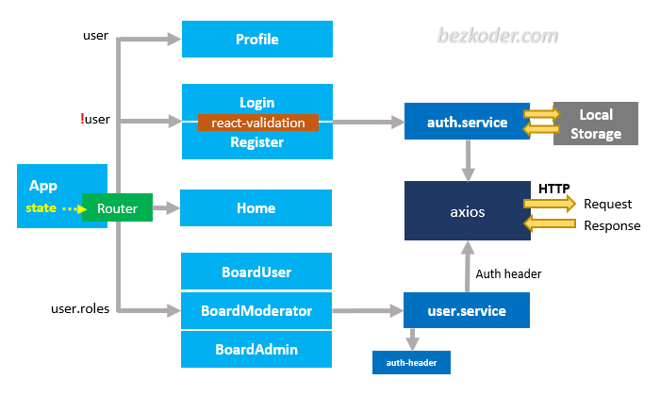

**Admin Board**

**Teacher Board**

**Student Board**

Figure 1 Authentication and Role Check

Admin Board

Student Section

Teacher Section

Add New Student

List OF Student

Update Student

Delete Student

Add New Teacher

List OF Teacher

Update Teacher

Delete Teacher

LogOut

Profile

Figure 2 Admin Activity Diagram

Teacher Board

Student Section

List OF Student

Update Attendance

Feedback

LogOut

Profile

Figure 3 Teacher Activity Diagram

Figure 4 Student Activity Board

Student Board

Feedback

LogOut

Profile

## Data Flow Diagram

Figure 5 Level 0 Data Flow Diagram

User

School Management System

User

User

Admin

Teacher

Student

User

Figure 6 Level 1 Data Flow Diagram

Admin

Admin

Figure 7 Level 2 Data Flow Diagram For Admin

Teacher

Teacher

Figure 8 Level 2 Data Flow Diagram For Teacher

Student

Student

Figure 9 Level 2 Data Flow Diagram For Student

## Use Case Diagram

<< extends >>

<< extends >>

<< extends >>

<< extends >>

<< extends >>

<< extends >>

<< extends >>

<< extends >>

<< extends >>

Admin

Student

Teacher

Figure 10 Use Case Diagram

## ER Diagram

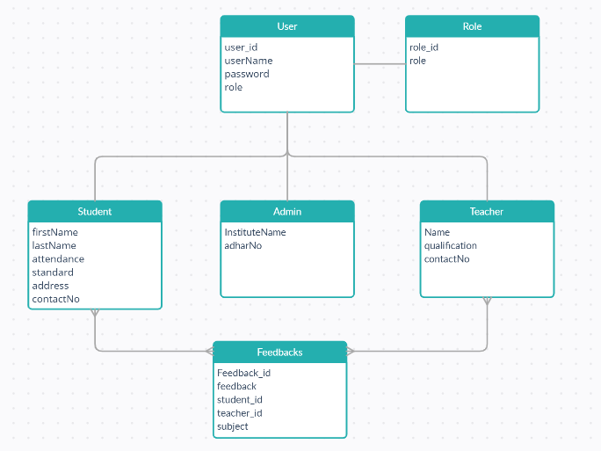

Figure 11 ER Diagram

## Database Design

User:

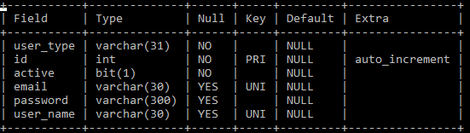

Figure 12 User database design

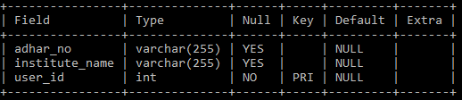Admin:

Figure 13 Admin database design

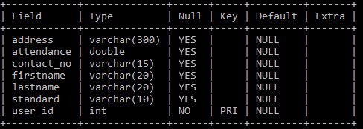Student:

Figure 14 Student database design

Teacher:

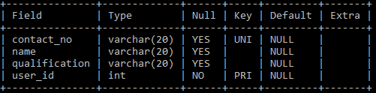

Figure 15 Teacher database design

Role:

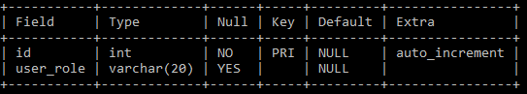

Figure 16 Roles database design

User_roles:

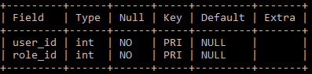

Figure 17 User_roles database design

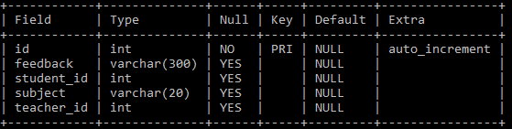Feedbacks:

Figure 18 Feedback database design

# Snapshots

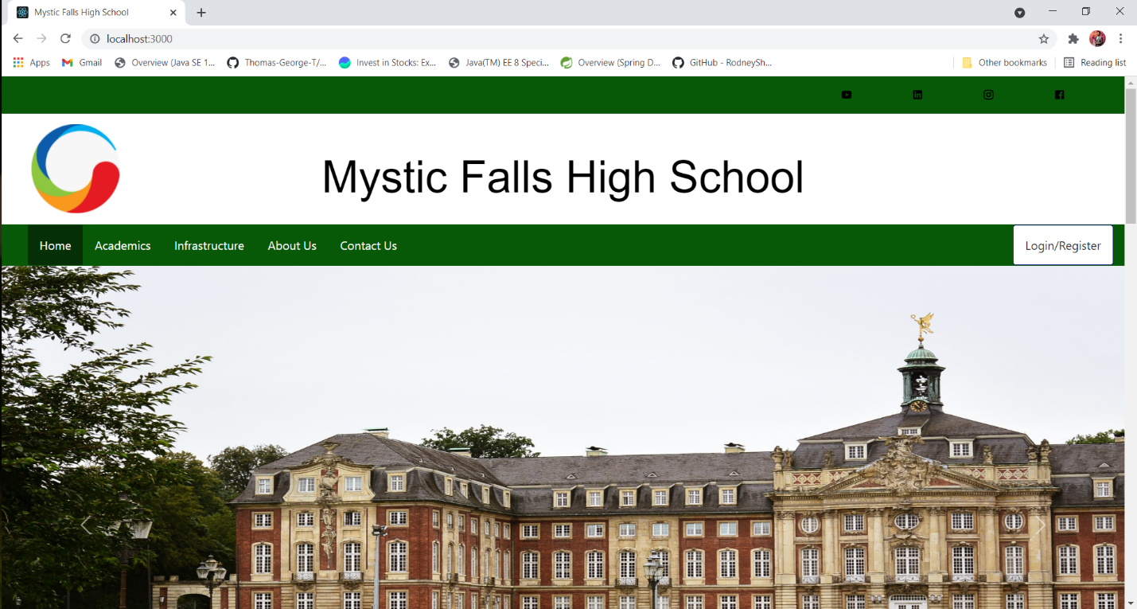

Figure Snapshot Home Page

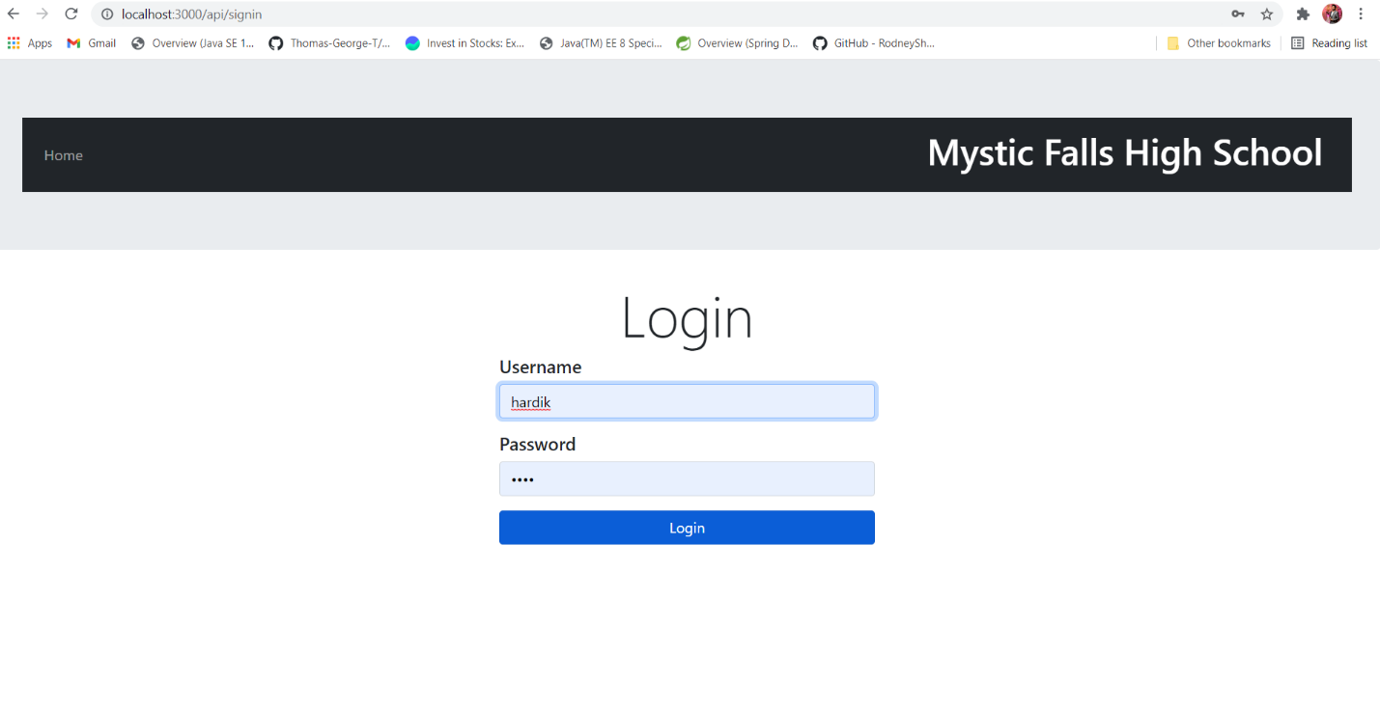

Figure 20 Snapshot Login Page

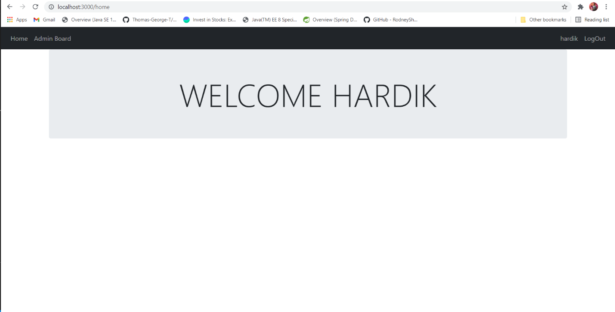

Figure Snapshot Admin Homepage

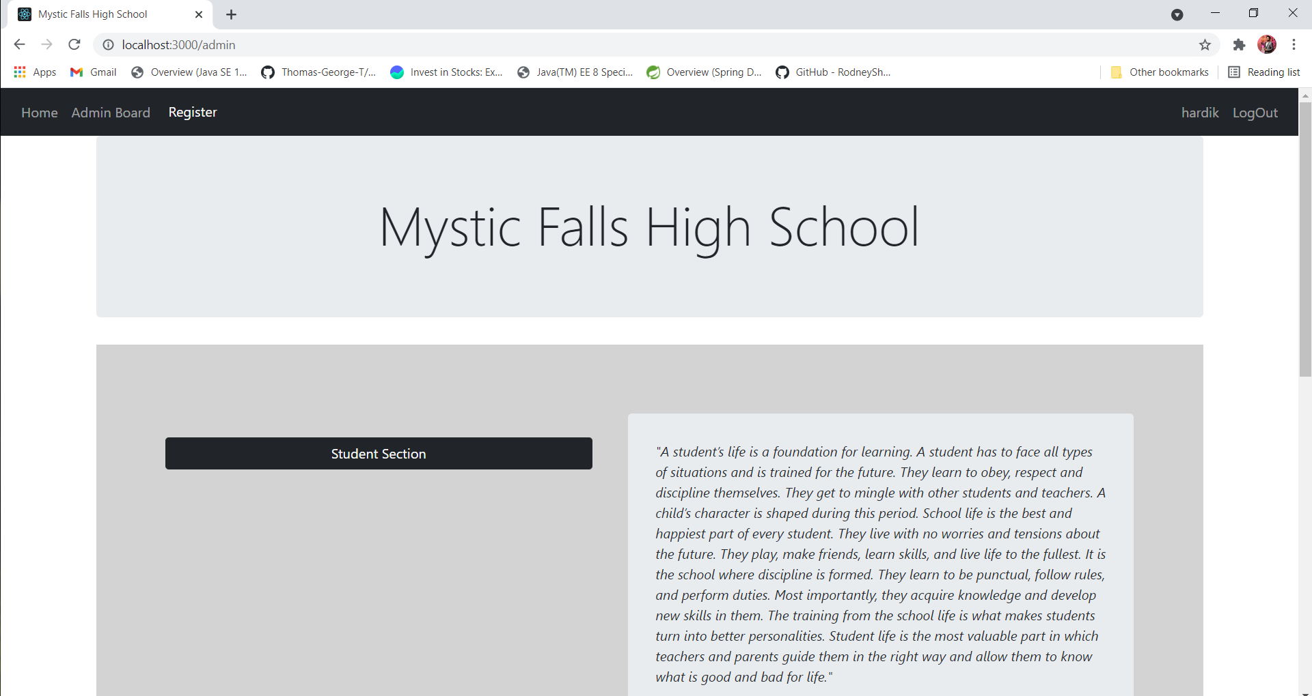

Figure Snapshot Admin page

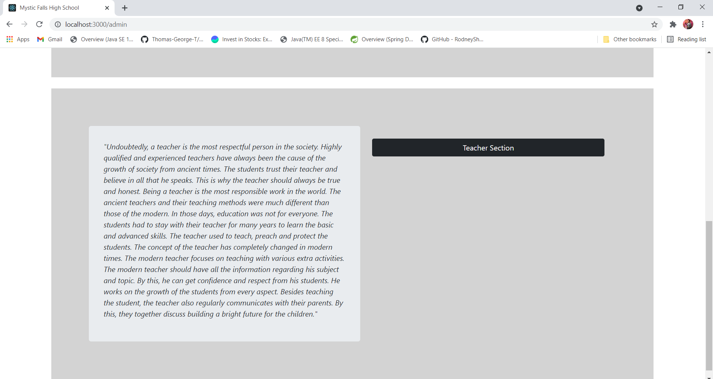

Figure Snapshot Admin Teacher Section

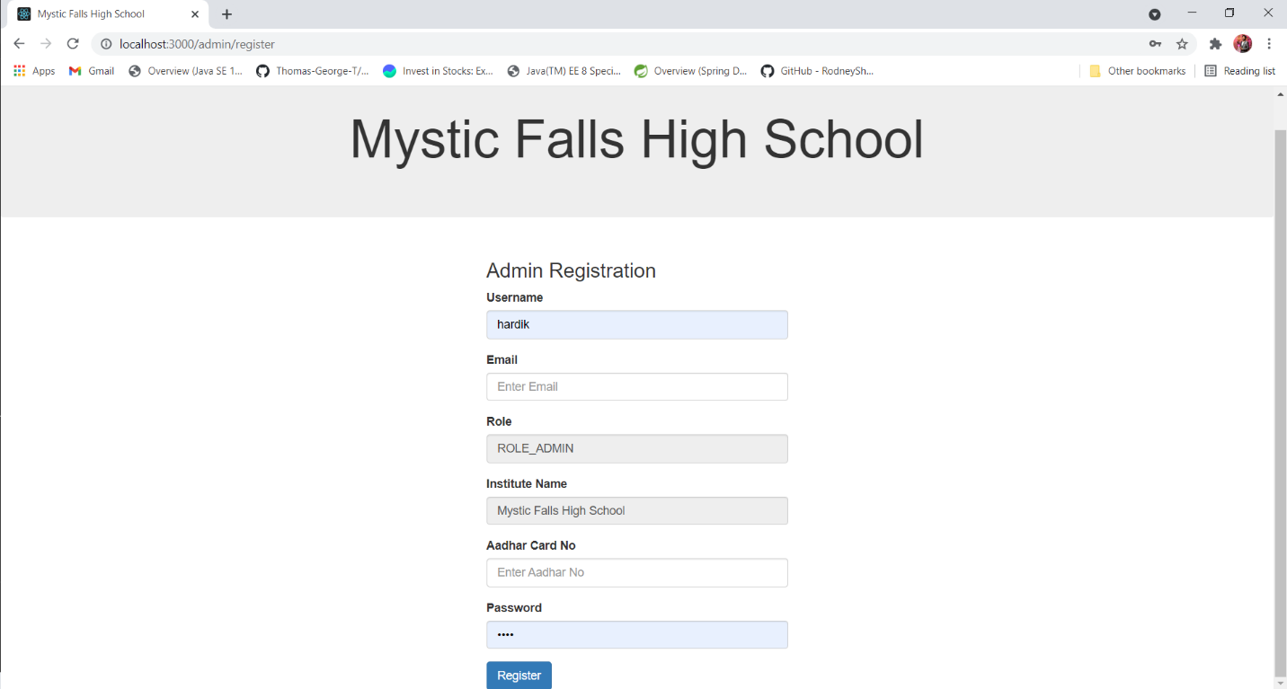

Figure 24 Snapshot Admin Registration

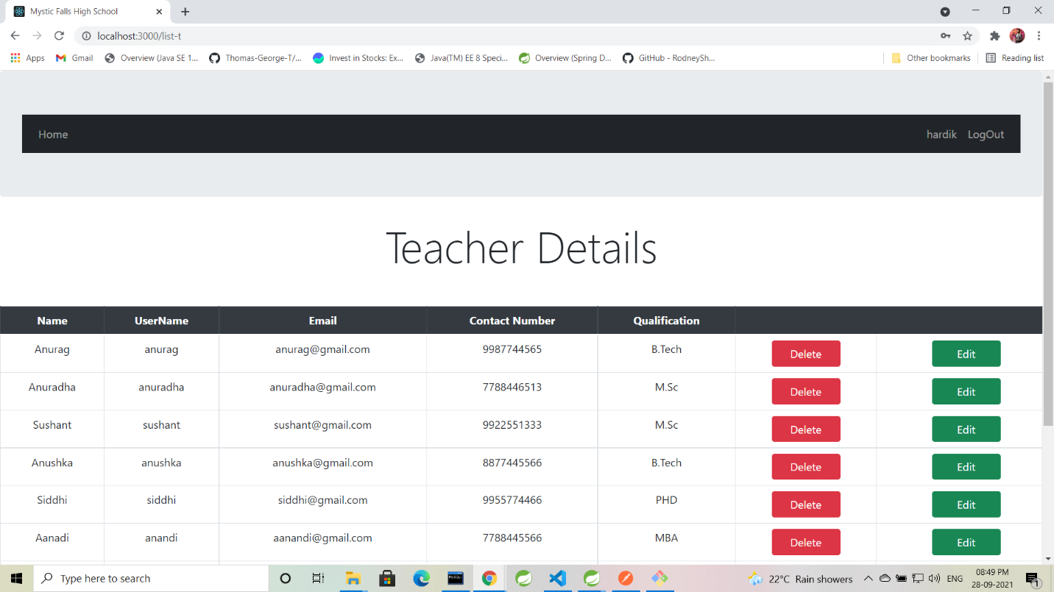

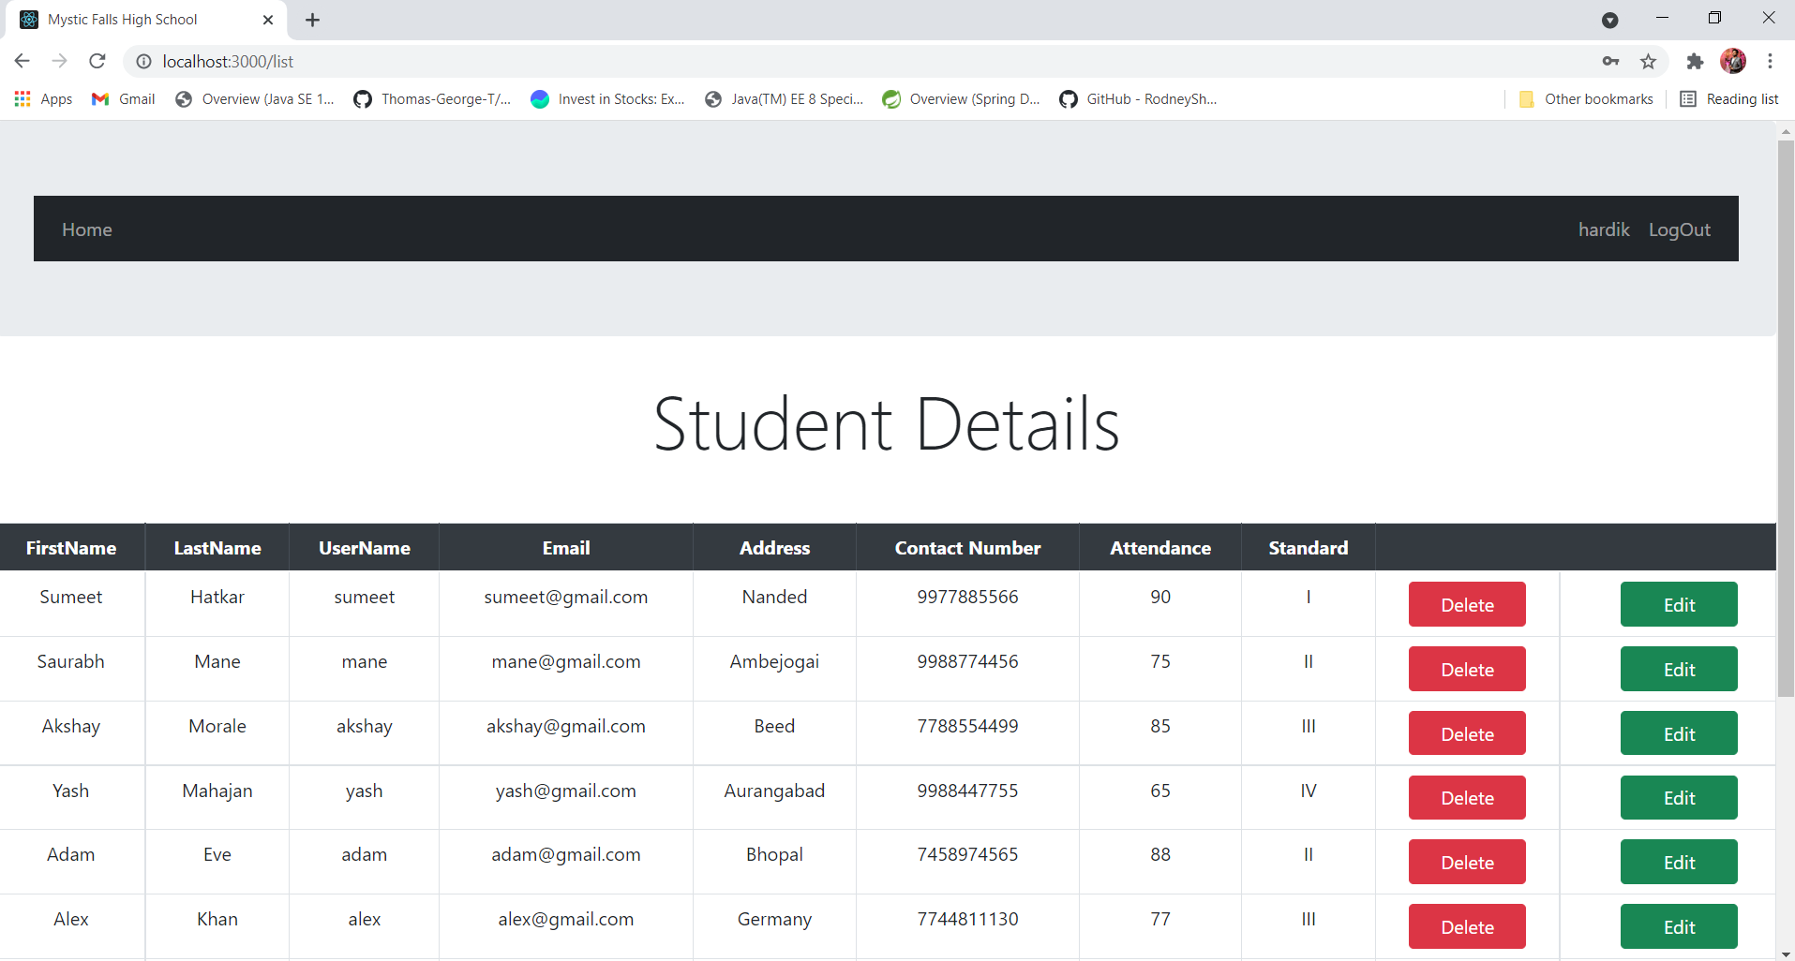Figure Snapshot Admin Teacher_list

Figure 26 Snapshot Admin Student_list

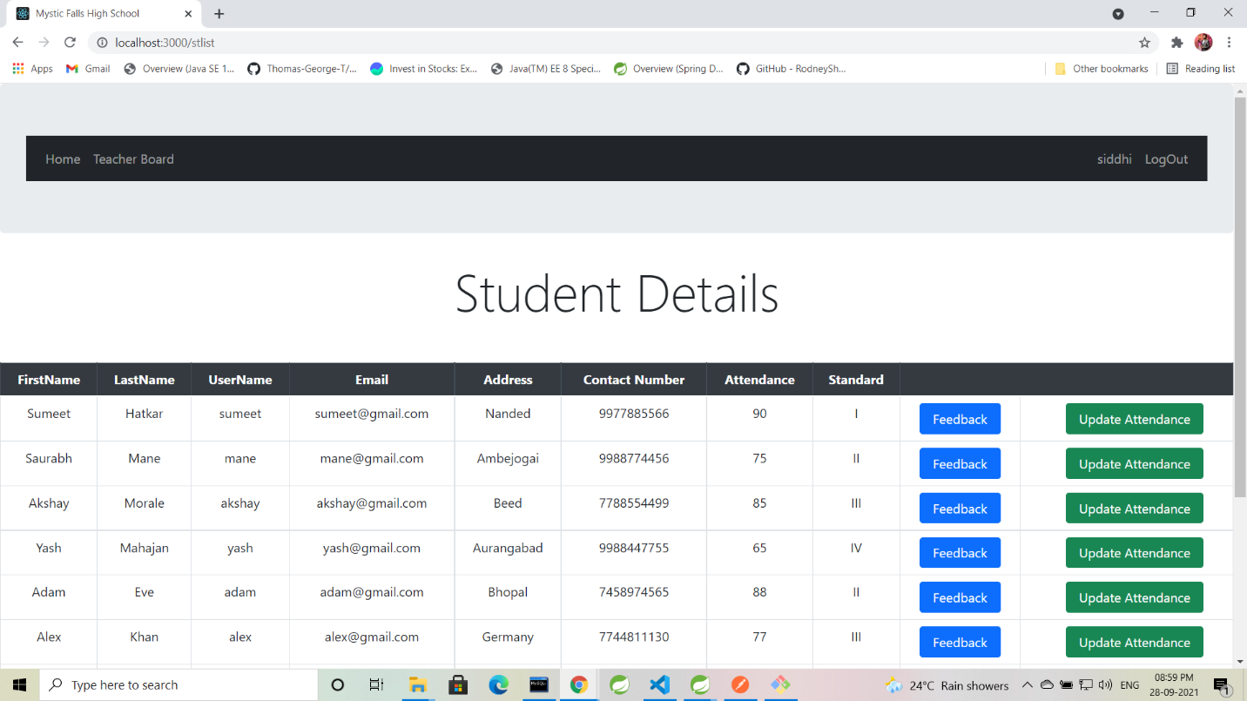

Figure Snapshot Teacher student_section

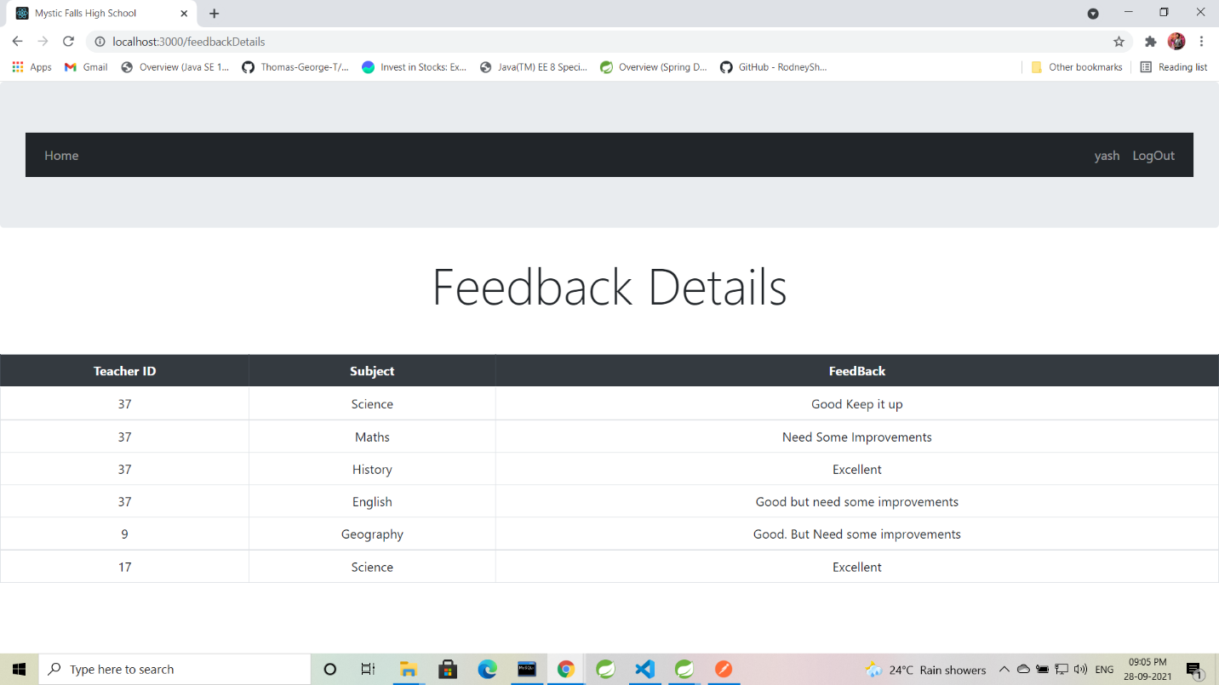

Figure 28 Snapshot Student Details

# Future Scope

The current ongoing situation of pandemic in this world where everything has stopped and still, and everything has hit badly, even education system. Hence,

School Management system if developed at its full can be a great platform for education system. A web application where administration of school can handle all management work easily and maintain records of students and teachers from anywhere on this planet and reduce a lot of paperwork. Management can also collect fees via payment gateway and provide receipts which can lead to reduce a lot of paperwork and it can maintain the records in database so no more hectic tensions of maintaining receipt books, log books. All transactions will be online and recorded so no more misunderstandings and frauds.

Where as for teachers it will be a very great mode to maintain attendance, maintain student’s result records. Also, teacher can provide assignments, notices and many more.

Student is the most important part of a School and education system. So, for them this application will be the most beneficial platform. Student can track his/her progress and analyze his strengths and weaknesses and plan accordingly. Students’ will be able to view their attendance report, their daily feedbacks/remarks subject-wise from respective subject teacher. Students can also get their assignments and they can even upload their completed assignments, view due dates, etc. Students could get online lectures, recorded sessions, notes and more study material. Students can also view their daily schedule or their monthly time-table. Even they can get any urgent notices. Students can pay their fees, collect receipt and keep it safe in their profile.

**Conclusion**

Online School Management System provides better platform to get connected with Students and Teachers efficiently. Our System provides a very user-friendly platform where students can easily look for the feedbacks provided by faculties of school which eventually help them in self-improvement. Also, teacher can update attendance and feedback for particular subjects. The software is flexible enough to be modified and implemented as per future requirements. We have tried our best to present this free and user–friendly website to School members.